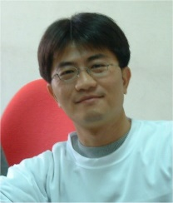
Dr. Yen-Hung Chen received his Ph.D. degree in nuclear science in 1999 from National Tsinghua University, Hsinchu, Taiwan. He is currently a professor with the Department of Optics and Photonics, National Central University, Taiwan. His research interests are in the areas of nonlinear optics, integrated photonic circuits, integrated quantum photonic sources and devices, integrated multifunction solid-state lasers, and quasi-phase-matching technology.

